Module 9: How to Facilitate Workshop 8
Mental Health, Relationships, & Money; Financial Crisis Planning

Part 1: Introduction to Workshop 8
Welcome back to MHAAO’s Money Basics Facilitator Training!

In this Module, you will learn how to facilitate Workshop 8. This workshop focuses on the relationships between mental health and addiction challenges, money, and economic insecurity.

In this workshop, participants will learn how to create a Financial Crisis Plan. They will also learn about how financial stress and money issues can affect a person’s relationships, how to communicate about money with one’s partner, and how to identify financial or economic abuse.

The advanced preparations for Workshop 8 are located in the Facilitator Guide, which will also provide time estimates for each topic and page numbers that correspond to the Student Guide for the topics.

There are a number of additional helpful handouts, resources, and videos located in the Facilitator Toolkit. The videos focus on the topics of mental health and poverty, barriers to mental health care for BIPOC communities, and what Representative Payees are.
As always, you will begin each class by welcoming back the participants, facilitating a quick check-in about how their homework assignments went, reviewing the Community Agreements, and providing students with a quick overview of the agenda for that workshop.
Part 2: How to Facilitate a Conversation about Behavioral Health Challenges and Money
You will begin this workshop with a discussion of the two-way relationships between mental health challenges and money. You can go over the examples in the Student Guide on how financial stress can affect a person’s mental health and wellbeing and how a person’s mental health can affect their financial situation.
Some examples include:
- If an individual’s ability to work is affected by their experiences with mental health and/or addiction challenges, they may experience a sudden drop in their income.
- Living in poverty has been shown to cause continual stress, which impacts a person’s mental and physical health and well-being.
- Hospitalizations can not only interfere with a person’s ability to access their personal finances while hospitalized, but the bills afterward can be overwhelming.
Using the information in the Student Guide, you will discuss how numerous psychological studies have shown that poverty and financial stress can take a serious toll on a person’s mental, emotional, and physical health and well-being. For example, lower-income adults and children are much more likely to develop mental health challenges, particularly anxiety and depression.
Bring the conversation back to the discussion of intersectionality and poverty from Workshop 1.
Groups experiencing structural barriers to economic mobility often also experience discrimination in their daily lives, which psychological research has shown to exacerbate stress as well as anxiety and depression. Discrimination, particularly racism, is a type of interpersonal trauma.
Financial stress can disproportionately impact marginalized communities, especially low-income, housing insecure, disabled, and transgender folks and/or BIPOC communities due to racism, ableism, transphobia etc. in our country’s systems, laws, and policies.
Poverty is an intersectional issue and experiencing discrimination because of one’s class, gender, sexuality, race/ethnicity, ability, nationality, religion, and more can take a serious toll on a person’s mental health and well-being.
There are some videos and additional resources in the Facilitator Toolkit. It is recommended that you review these resources and do your own research on how discrimination impacts mental health and the structural barriers to behavioral health services for marginalized groups. This will help prepare you to lead thoughtful, well-informed conversations with participants about these important and heavy topics.
Next, you will read through and discuss the financial and personal costs of substance use and gambling addictions as outlined in the Student Guide.
Addictions of all types can take their toll on a person’s finances and on other parts of their lives, including their relationships and job status.
Pay special attention to the section comparing the costs of treatment and recovery versus the costs of continuing down the path of addiction.
Early intervention reduces the risk of illness, injury, and increased legal fees and insurance rates, and can allow for the completion of educational, professional, and personal goals. The cost of treatment amounts to very little in the big picture.

Part 3: How to Facilitate a Conversation on Financial Stress & Physical Health Challenges
Using the information in the Student Guide, you will lead a discussion on how financial stress can impact a person’s physical health, and vice versa.
For example, chronic financial stress has been linked to a number of physical health issues, such as migraines, heart disease, diabetes, insomnia, and more.
Emphasize the importance of keeping an emergency savings fund for potential health problems and the importance of having health insurance. Here you can provide information on how participants may qualify and access free health care through Medicaid.
Then, read through the tips for reducing financial stress in the Student Guide and ask the participants to brainstorm any additional tips, writing them down on the whiteboard. Encourage participants’ input and questions at any point during this section.
Note that by taking this training and facilitating this course to your community, you and your group of participating peers will be taking important steps toward reducing financial stress and taking care of your mental and financial health and well-being.

Part 4: How to Create a Financial Crisis Plan
In this section, participants will follow the steps in the Student Guide to create a Financial Crisis Plan, using the Workshop 8 Worksheets.
You can ask the participants to form pairs or small groups so they can work together and help each other in creating their plans. Ask them to follow the steps in the Student Guide to complete these worksheets
Step 1: Participants will out the first worksheet, which has two sections. Section one is “How financial issues affect me” and section two is “How mental health and/or addiction challenges, treatment, and/or physical health issues affect my finances.” Participants will mark “never,” “rarely,” “sometimes,” or “often” for each of the items on the list.
This is to help participants identify the ways in which their mental health is affected by their current financial issues or stressors and vice versa.
*include worksheet as example graphic in video* (hard to understand unless you see it)
Step 2: Fill out the Financial Crisis Plan worksheet. This worksheet has two options. One is: “When I do or experience this, I will do this instead” and the other is: “Rather than doing this, I will do this instead.” Participants can choose to focus on one, or both, of these prompts.
Facilitators should do this activity as well and be available to answer any questions.
Once everyone has finished up their plans, ask the participants to share something about the experience or something they noted in their plans, if they are comfortable, and write their thoughts on the whiteboard. Facilitators should share as well.
Step 3: Participants will follow the instructions in the Student Guide to make a list of their expenses and when payments are due. This can help participants keep track of their bills and other monthly expenses.
Participants can refer back to their list of expenses from Workshop Three and can do this activity alone or in pairs.
Step 4: The last bit of the Financial Crisis Plan process is the option for participants to identify a trusted friend, family member or mentor to help them keep track of their finances during times of crisis.
In this section, you will also talk about a person’s rights when it comes to Representative Payees. There are some videos in the Facilitator Toolkit on Representative Payees that may be helpful to include.
Part 5: How to Facilitate a Discussion on Relationship Issues & Money
Ask the participants to journal for a few minutes in the space in the Student Guide or in their own notebooks about how financial stress has affected or can affect their relationships. These can be relationships with their partners, their friends, and/or their family members. After 2-3 minutes, open the class up for discussion. Facilitators can share their own experiences and invite the participants to share what they feel comfortable sharing.
Using the information in the Student Guide, you can go over the ways in which relationship problems can occur due to different opinions about money, lack of communication about money, or economic inequality between partners.
Next, you will read through the tips for effective communication about money and financial stress in a relationship, as outlined in the Student Guide, and brainstorm other suggestions. Write participants’ suggestions on the whiteboard.
Part 6: How to Facilitate a Trauma-Informed Conversation about Financial Abuse
This section deals with a form of domestic abuse –economic abuse – which may be a difficult topic for some participants. Approach these topics thoughtfully and with empathy. Be transparent that these topics may be activating. This needs to be stated. Remind the participants that they always have the option to take a break from class or reach out to one of the facilitators for support at any time. Facilitators are there to provide support and resources
Using the information in the Student Guide, you will discuss what financial abuse is and the various ways it can occur, paying special attention to issues of manipulation, power, and control.
Financial abuse involves controlling a person’s ability to acquire, use, and keep financial resources. Economic abuse is very common in abusive relationships and is often the first sign of domestic abuse. Financial abuse may be accompanied by other types of abuse, or it may stand alone as a form of control and manipulation.
Examples can include preventing the survivor from working, restricting or stealing money, and manipulating and intimidating the survivor.
Discuss how emotional abuse, such as financial abuse, is often more difficult to identify than other forms of domestic abuse but that doesn’t make it any less devastating. Controlling a person’s income and restricting their financial independence can trap a survivor in an abusive relationship.
Go through the warning signs of financial abuse in the Student Guide. Some examples from this list include:
- A person’s partner controls all of the household finances. The person’s name is not on the household checking account or on joint purchases like car loans, mortgages, cell phone plans, or apartment leases.
- A person’s partner is trying to control their use of, or access to, money they earned or saved.
- A person’s partner requires them to bail them out of financial crises
- A person’s partner criticizes their job, pressures them to quit, or harasses them at work.
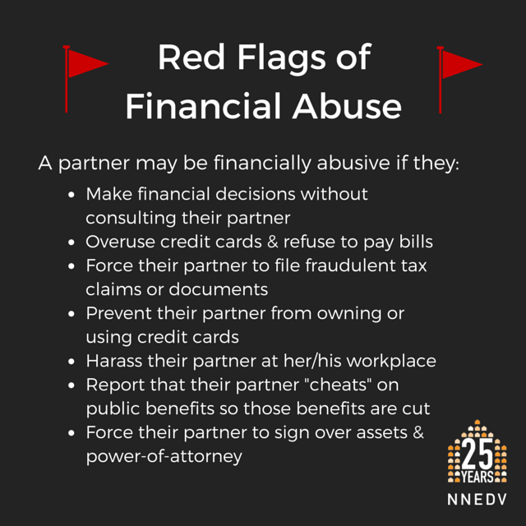
Let participants know that if they or someone they know identifies with any of these warning signs of financial abuse, they are not alone and there are many resources and forms of help available. Go through the list of resources in the Student Guide.
It would likely be helpful for facilitators to do research on local resources and shelters for survivors of financial abuse or any type of domestic abuse and share these resources with the class. If you think it would be helpful, you may choose to send out a resource list after class.
There is additional information about financial abuse, safety planning, and resources for survivors located in the Facilitator Toolkit.
Part 7: Wrap Up
Like every workshop, you can wrap up the class by allowing space for questions and comments and by reviewing the homework assignments. You are encouraged to fill out the “Facilitator Reflection” form at the end of every class and meet up with your co-facilitator to plan for the next class.
Congratulations, you’ve completed Module 9 of the Money Basics Facilitator Training! Before you continue with your day, please complete the review questions and check out the homework assignments.

